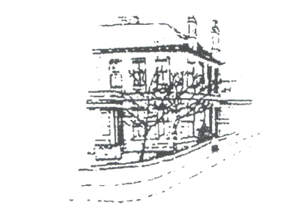
Dr David I Matthewson (GMC 3493953) Racecourse Road Medical Group
Dr Aileen Good (GMC 6128602) 3 Racecourse Road Dr Peter Paton (GMC 6026511) AYR KA7 2DF
Dr Carolyn Adams(GMC 4706568) Telephone No: 01292 Tel No: 01292 886622
Dr Calum Dobbie (GMC 3589333) Fax No: 01292 269774
Dr Vanessa Young (GMC 7036969) Website: www.rrmg.co.uk
Dr Lee-Anne Haddow (GMC 6077811)

carERS IDENTIFICATION AND REFERRAL FORM

DO YOU LOOK AFTER SOMEONE WHO IS
ILL, FRAIL, DISABLED OR MENTALLY ILL?

If so, you are a carer and we would like to support you.
Please complete this form and hand it in to reception.

If you are agreeable, we will pass your details to the Carers Service, which is a countywide organisation providing relevant information and advice, local support services, newsletter and telephone linkline for carers.

YOUR DETAILS:
Name
Date Of Birth
Address
Post Code
Telephone Number
Any relevant information

DETAILS OF THE PERSON YOU LOOK AFTER:
Name
Date Of Birth
Address
(If Different From Above)
Post Code
Telephone Number
(If Different From Above)
GP Details
(If Different From Your Own)
□ Please tick if you wish us to pass your details to the Carers Service▫

Thank you for completing this form

AGREEMENT FOR A CARER TO HAVE ACCESS TO A PATIENT’S PERSONAL DETAILS and/or COPIES OF CORRESPONDENCE

Patient’s Name
Patient’s Address

To: [Insert Practice name]
I give permission for my Carer [Insert Carer Name] to have access to my medical records and personal details held by the Practice.

This permission relates to all / part of my record / specific condition only (delete as appropriate).

Where the permission is restricted to part of the record only, please specify below the precise limits of this permission, and any areas of the record which are excluded.

_________________________________________________________________________________________________________________________________________________________________________________________________________________________________

I understand that the doctor may override this authority at any time, and that this permission will remain in force until cancelled by me in writing.

I consent to my Carer receiving copies of all correspondence relating to my treatment (delete if not applicable). I confirm that this has been explained to me by my GP and that the GP has sole discretion to withhold all or any copies.

Signed _______________________________ (Patient)

Date _________________________________

Accepted by ___________________________ (Doctor)

Date _________________________________

Office Use Only:

Copy Frequency

Specific Copy Exclusions

Specific Copy Inclusions

CONTACT POINTS

RESOURCE | CONTACT NUMBER
Carers UK  www.carersuk.org | 0808 8087777
Princess Royal Trust for Carers  www.carercentre.com | 01264835246
Community Nursing Service | 01292 513876
Occupational Therapy | 01292 281993
Social Services | 01292 610225
Women’s Royal Voluntary Service (WRVS) | 0141 8889 7645
Local Carer’s organisation  www.southayrshire.carers@unity-enterprise.com | 01292 263000
Social Work Department  Overmills Day Care  2a Westwood Avenue  AYR KA8 0QZ | 01292 281993

