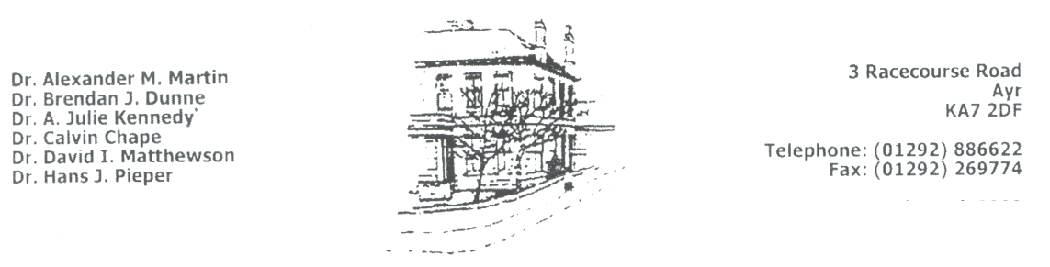
Lung function
(Spirometry) Test

You have been asked to have a Lung Function Test (Spirometry). This leaflet is to give you information so you can be well prepared for the test to ensure that most accurate results are obtained.

Spirometry is a test that can help diagnose various lung conditions, most commonly chronic obstructive pulmonary disease (COPD).
Spirometry is also used to monitor the severity of some other lung conditions and their response to treatment.

Although spirometry is very useful for helping to diagnose some conditions and monitor their treatment, a normal spirometry test does not necessarily rule out some forms of lung disease as there can be periods when spirometry tests can be normal even where a lung condition exists, such as asthma.

How is it done?

If it has not already been done, you will have your weight and height measured. For the spirometry itself, you need to breathe into the spirometer machine.

First you breathe in fully and then seal your lips around the mouthpiece of the spirometer.
You then blow out as fast and as far as you can until your lungs are completely empty. This can take several seconds. You may also be asked to breathe in fully and then breathe out slowly as far as you can. Depending on the results, you may be given four puffs of an inhaler and the test repeated.

The test requires maximum effort so it is important that you are as fit and well as possible. Please inform staff prior to appointment if you have had any of the problems listed below in the past 2-3 months:

- Unstable angina
- Collapsed lung
- Heart attack or stroke
- Operations e.g. hernia/eye surgery or abdominal surgery
- Ear infections/ear perforations

The test will not be reliable if you are being treated (on antibiotics) or recovering from a chest infection in the last six weeks. If this is the case, please postpone the test until six weeks post recovery.

Instructions to follow on the day of the test:

- Please wear loose fitting comfortable clothing
- Arrive 10 minutes before appointment time
- Do NOT have a large meal within 2 hours of the
appointment
- Do NOT smoke or have any alcohol that day
- Do NOT exercise for 1 hour prior to the test

It is important that you note the timings below with regard to taking your inhalers before the test:

- Do NOT use BLUE SALBUTAMOL inhaler for 4 hours prior to your appointment
- Do NOT use SPIRIVA 36 hours to test
- Do NOT take any other inhalers on the morning of your appointment

Please bring ALL your inhalers in with you. This appointment can take up to 45 minutes.

If you have any queries regarding any of the above information prior to your appointment, please do not hesitate to contact us.

