

Ayrshire and Arran Chronic Pain Online Self-Management Course

New intensive self-management course for those living in Ayrshire & Arran for helping you manage your chronic pain.

Chronic Pain is difficult to live with. It is hard to understand, you can’t see it and it varies day to day sometimes for no apparent reason. In addition to pain, people often experience frustration, anxiety, stress, sleeplessness, low mood, isolation, communication and relationship problems.

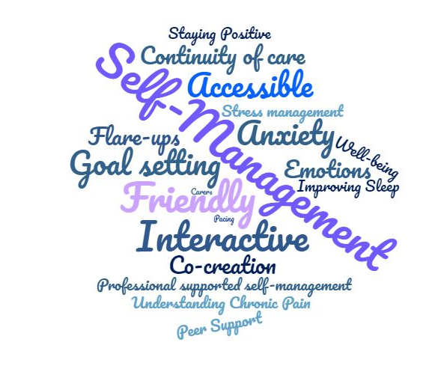

Times and dates are as following:
10.30-12.30
Tuesday 26th Jan
Tuesday 2nd Feb
Tuesday 9th Feb
Wed 17th Feb
Wed 24th Feb

Do you want to learn more about how you can manage your chronic pain?
Then email info@painassociation.com to find out more information and to book your place.

